***Question: Some students ask about the guidelines for the Research Project Proposal.***

***Answer: Project Charter document provides a good start, below show example of table of contents used in two different reports*.**

Example 1:

Table of contents for Research Proposal Project Document

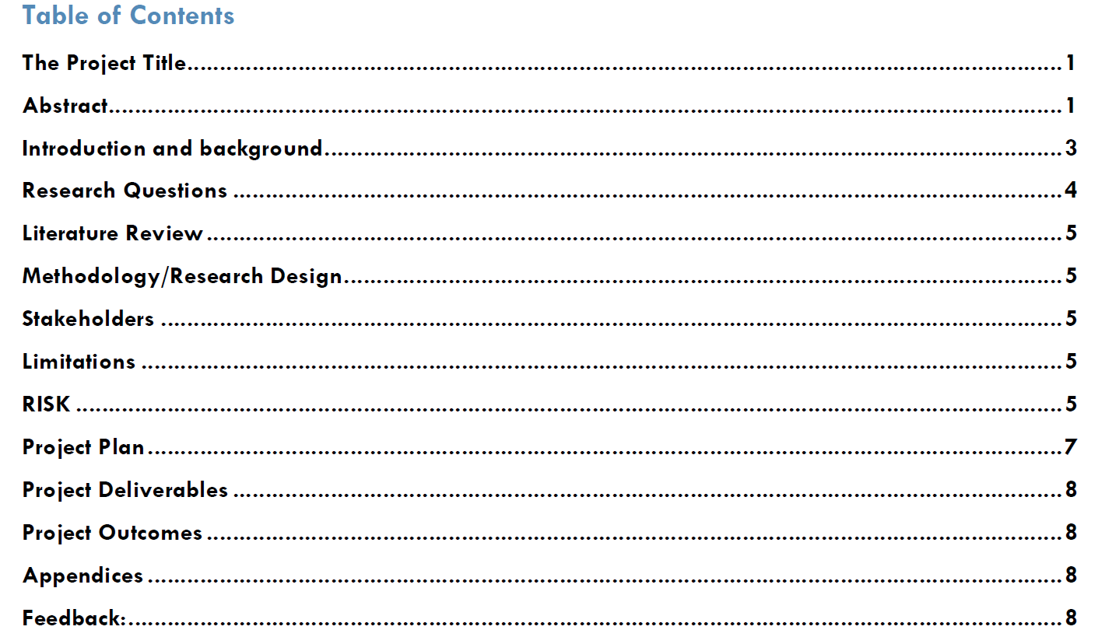

Example 2:

